**ASSIGNMENT 1**

**Problem Statement:**

loT - Based Industry - Real-Time River Water Quality

Monitoring and ControlSystem

**Topic**: Circuit design Home automation system in

TinkerCad

**Code**:

const int pingPin = 10;

const int ledUS = 2;

const int light = 7;

const int pir = 4;

int const PINO_SGAS = A5;

int const ledGas = 8;

int const button = 5;

int const motor = 13;

void setup(){

pinMode(ledUS, OUTPUT);

pinMode(light, OUTPUT);

pinMode(buzzer, OUTPUT);

pinMode(ledGas, OUTPUT);

pinMode(motor, OUTPUT);pinMode(pir, INPUT);

pinMode(button, INPUT);

pinMode(photoSensor, INPUT);

Serial.begin(9600);

}

void loop(){

long duration, cm;

int valLight = analogRead(photoSensor);

int valPIR= digitalRead(pir);

int valGAS = analogRead(PINO_SGAS);

valGAS = map(valGAS, 300, 750, 0, 100);

int valBt = digitalRead(button);

pinMode(pingPin, OUTPUT);

digitalWrite(pingPin, LOW);

delayMicroseconds(2);

digitalWrite(ping Pin, HIGH);

delayMicroseconds(5);

digitalWrite(ping Pin, LOW);

pinMode(pingPin, INPUT);

duration= pulseln(pingPin, HIGH);

cm = microsecondsToCentimeters(duratio n);

if(cm <336){digitalWrite(ledUS, HIGH);

}

Else

{

digitalWrite(ledUS,LOW);

if(valLight < 890){

digitalWrite(light, HIGH);

}

Else

{

digitalWrite(light, LOW);

if(valPIR == 1){

digitalWrite(buzzer, HIGH);

}

Else

{

digitalWrite(buzzer, LOW);

if(valBt == 1){

digitalWrite(motor,HIGH);

} else {

digitalWrite(motor, LOW);

if(valGAS > 20){digitalWrite(ledGas, HIGH);

}

else{

digitalWrite(ledGas, LOW);

Serial.print(val PIR);

Serial.println();

}

}

**OUTPUT:**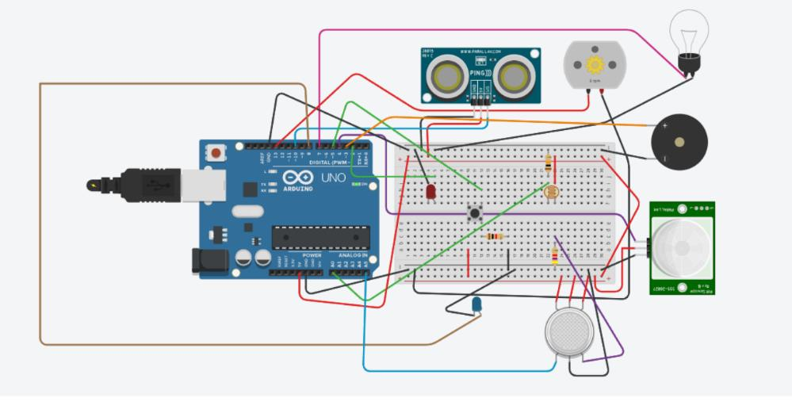

link-:https://www.tinkercad.com/things/a9eoYVyHKEO-terrific-amberis/editel